AI ASSISTED CODING
Assignment-02
Name: G. Siri Chandana
HT NO: 2303A51505
Batch-22
LAB 2:
Exploring Additional AI Coding Tools beyond Copilot – Gemini (Colab) and Cursor AI
Task-1: Use Gemini in Colab to generate a function that filters out all negative numbers from a list.
Output:
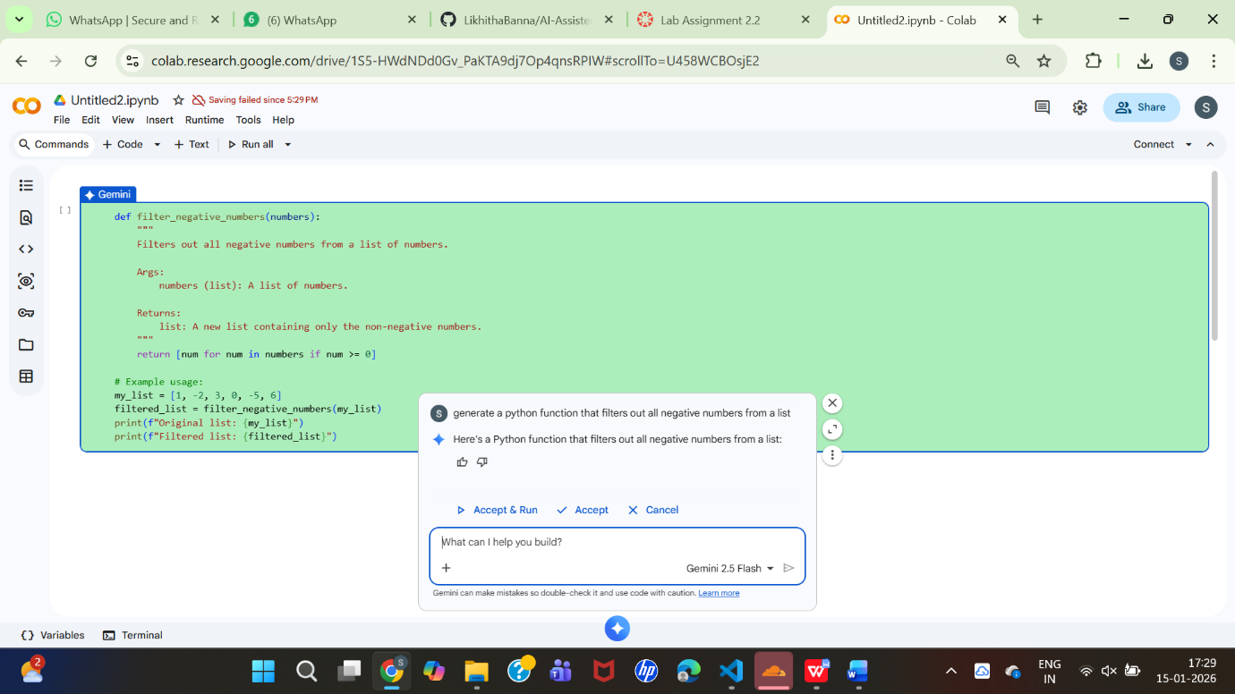
Before list and after list:
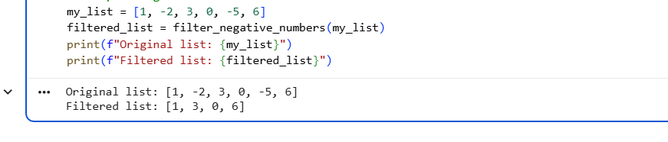
---------------------------------------------------------------------------------
Task-2: Use Gemini to generate a Python function that counts vowels, consonants, and digits in a string.
Output:
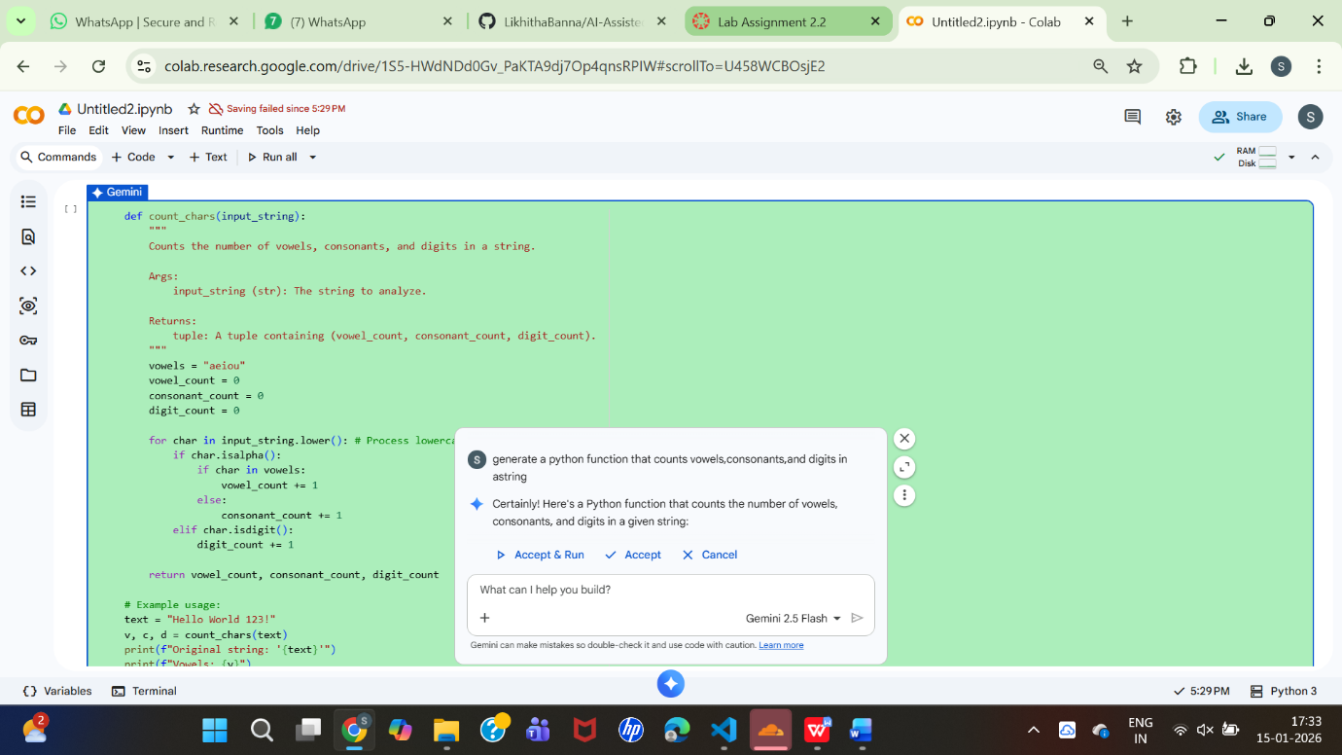

Sample Input and output:
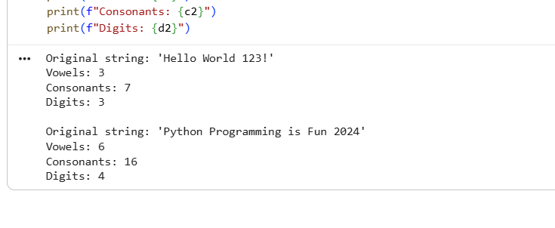
--------------------------------------------------------------------------------------------
Task-3: Generate a palindrome-checking function using Gemini and Copilot, then compare the results.
Generating using Gemini:
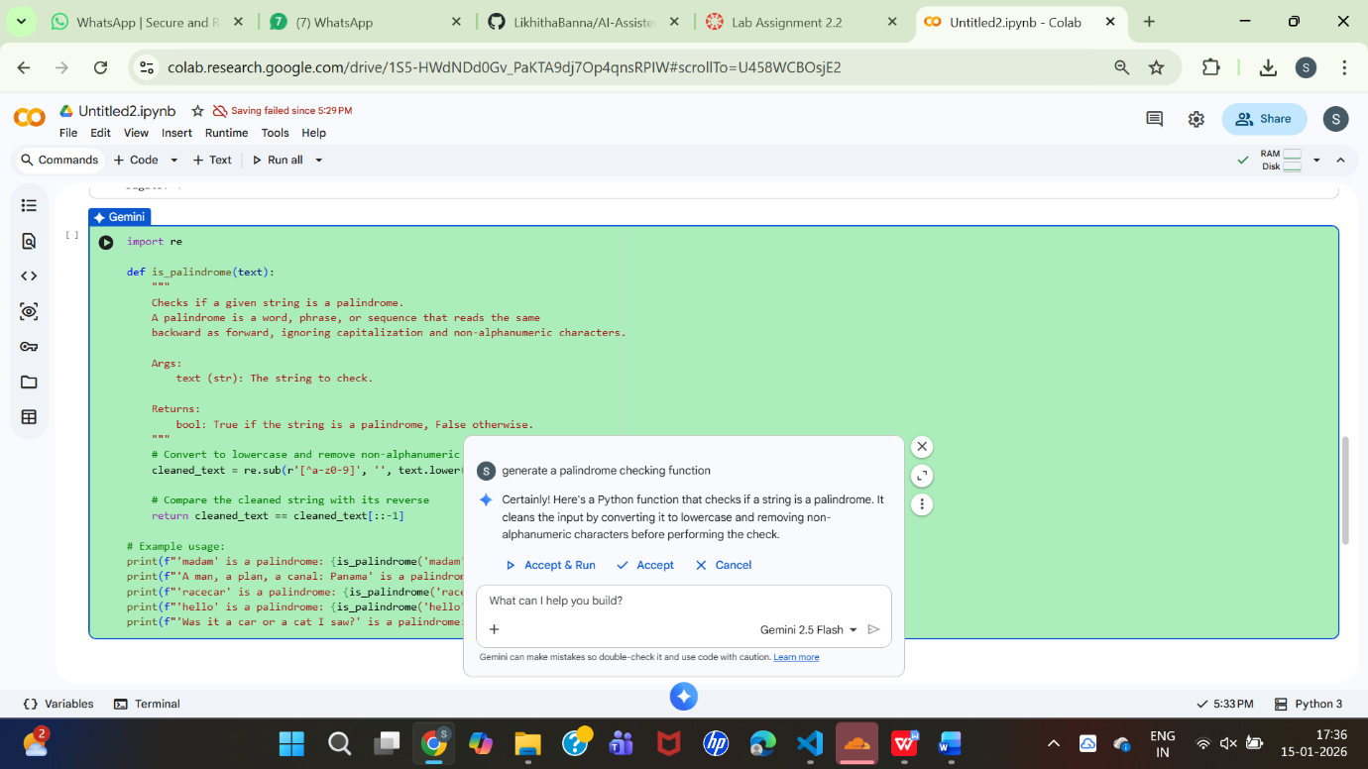

Sample Input and Output:
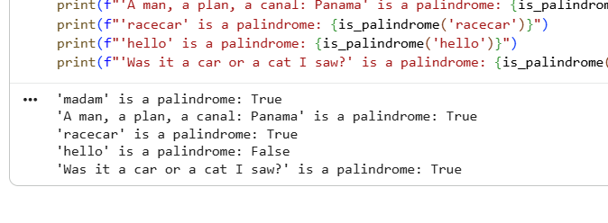
Generating using Copilot:
Prompt: #generate a palindrome checking function in python using user defined functions
Code:
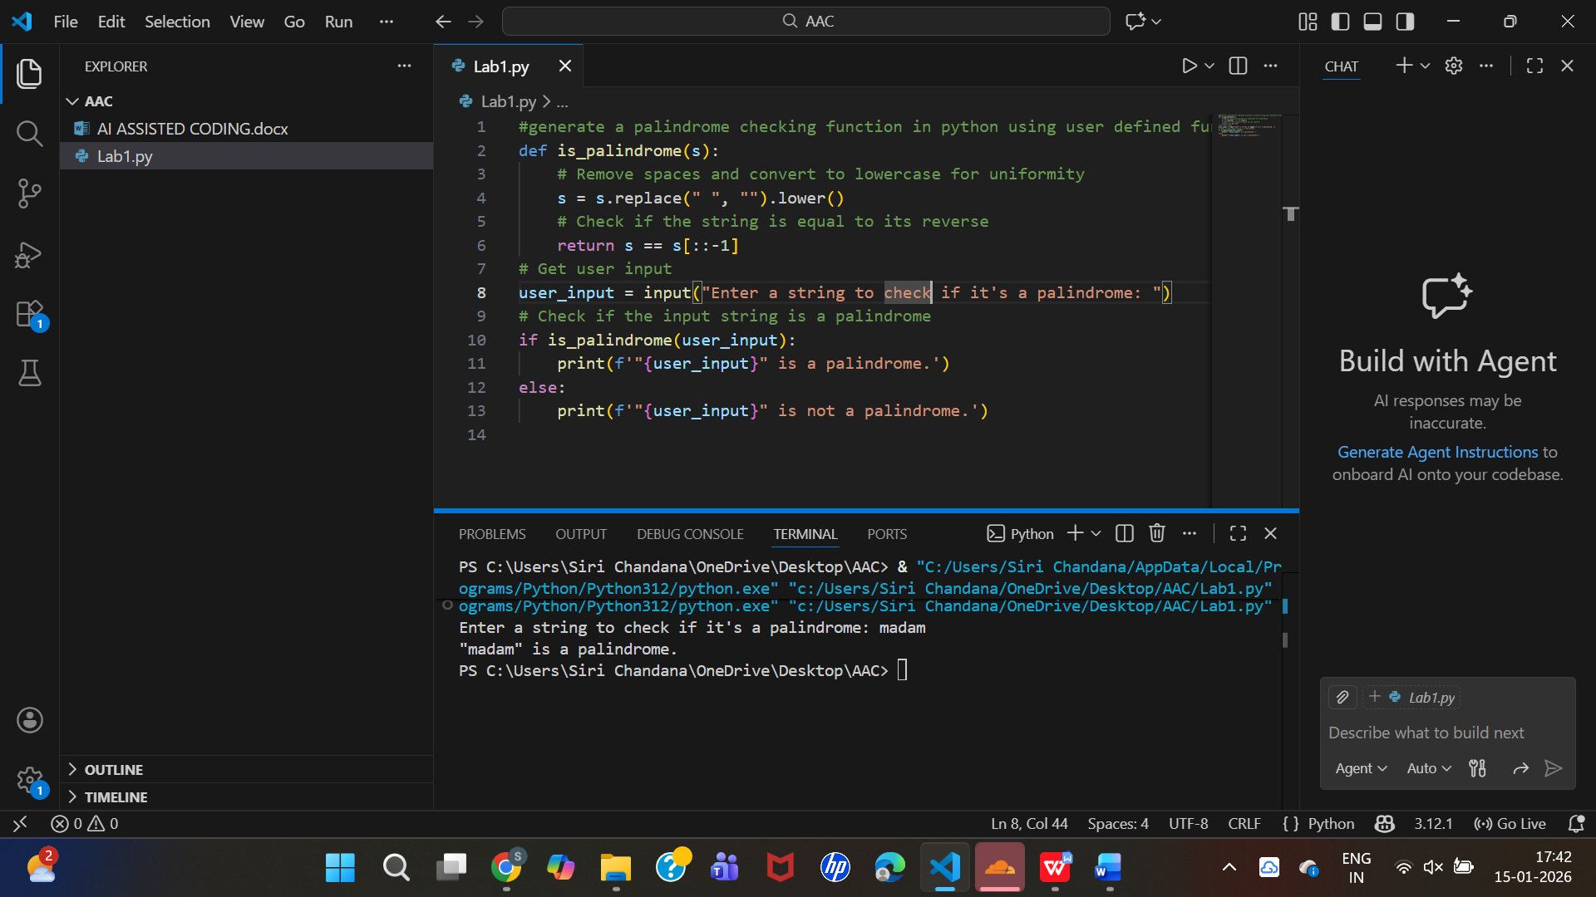
--------------------------------------------------------------------------------------------
Task-4: Ask Gemini to explain a python function (prime check or Palindrome check) line by line
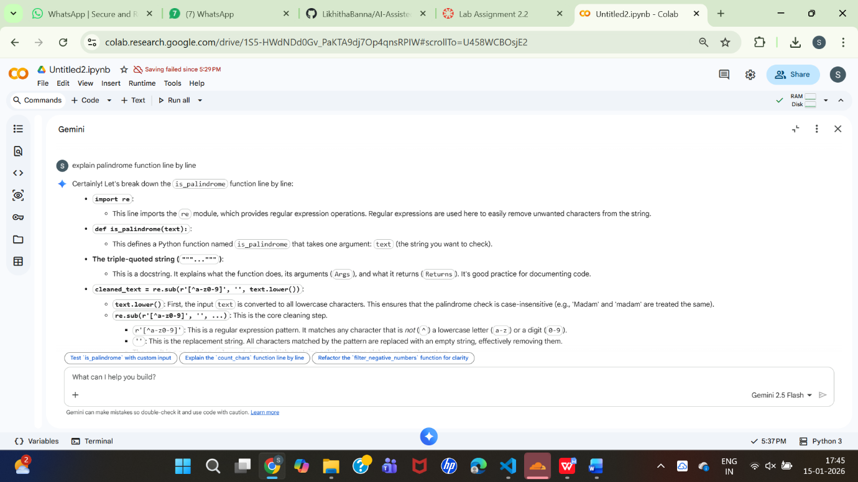
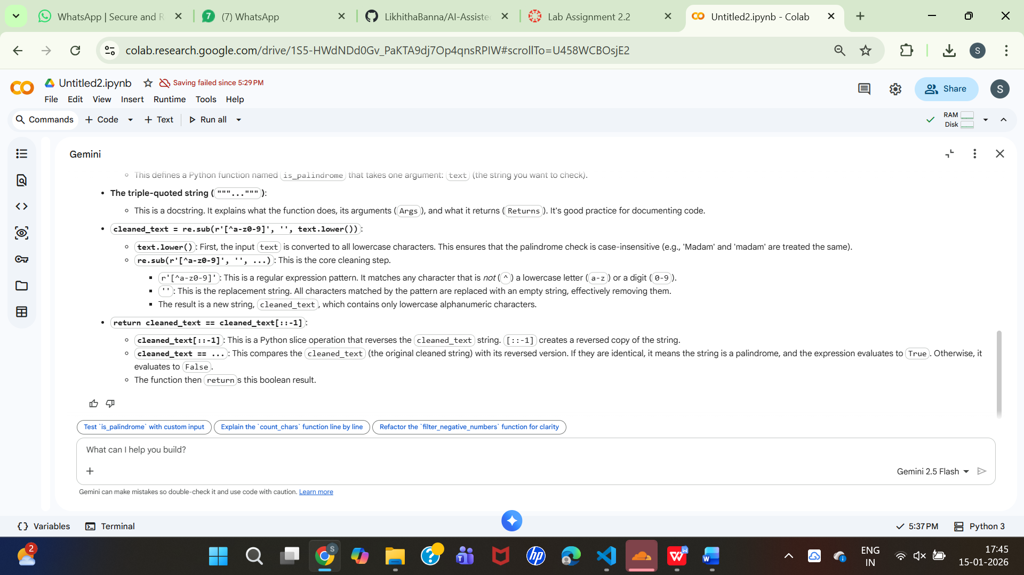
My own experience using both Gemini and GitHub Copilot:
While using Gemini in Google Colab, I found the explanations to be very clear and helpful in understanding the logic behind the code. Gemini was especially useful for learning and analyzing Python programs step by step. GitHub Copilot, was faster in generating code directly inside the editor and helped me complete tasks quickly. Copilot felt more suitable for continuous coding, while Gemini was better for conceptual clarity. Overall, using both tools together improved my coding efficiency and understanding.

